Abuse Awareness Training

Abuse Awareness Training is mandatory every year for all board members, coaches, team parents, umpires, and anyone who will be interacting with the players on a regular basis (parents who help coaches with practice and/or games)

1- Follow the Abuse Awareness Training link on the Foresthill Little League website or go to:
https://www.littleleague.org/university/articles/abuse-awareness-training-course/
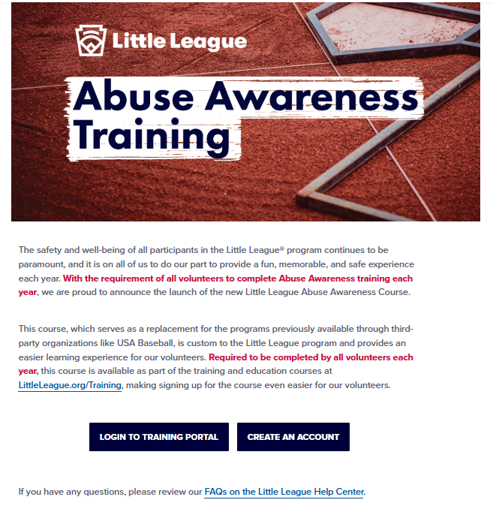

2- If you have never registered with Little League University, click on the blue “Create Account” button and follow the prompts to create a training account. Please select Foresthill Divide LL as your associated League at the bottom of this page.
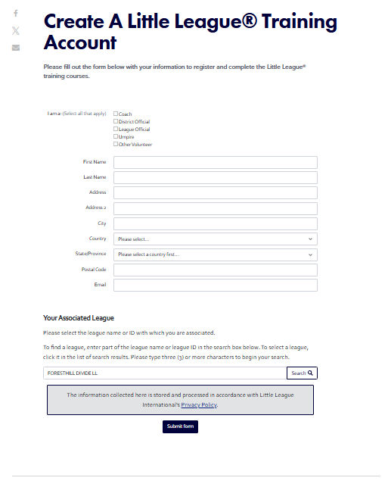

3- Once logged into the Little League University site please select the Abuse Awareness Training tab and complete the training.
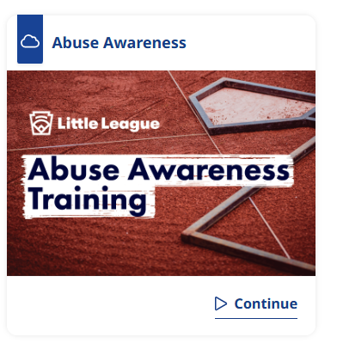

5- The training takes about 40min to complete and there will be a quiz to take at the end that you will have to pass. After taking the quiz, you will receive an email with the certification of completion. You MUST send/forward a copy to our Safety Officer at Safetyofficer@fdlittleleague.com for Little League records.

